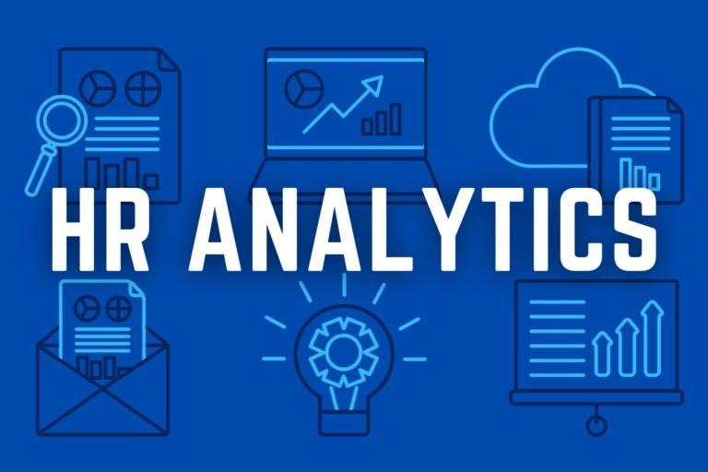

**Enhancing HR Analysis**

**Team Members:**

Sreeja Reddy Singidi

Sri Vamshi Polela

Nikroshitha A Notani

**INTRODUCTION:**

In the realm of Human Resources (HR), data analysis has become an invaluable tool for organizations seeking to optimize talent management, improve employee engagement, and drive data-driven decision-making. The purpose of this write-up is to provide a contextual understanding of HR data analysis and its broader landscape, using insights from the selected articles. Additionally, we will explore how these insights can enhance our group project on HR data analysis.

**Source :** <https://www.kaggle.com/datasets/saadharoon27/hr-analytics-dataset>

HR data analysis is the process of gathering, processing, and interpreting data to make informed HR decisions and predictions. The significance of HR data analysis cannot be overstated, as it enables organizations to address critical HR challenges, such as talent acquisition, employee retention, and workforce planning.

Our group project on HR data analysis seeks to address specific challenges within our organization, including improving employee retention and engagement. The insights gained from these articles will play a pivotal role in enhancing our project. For instance, we can apply predictive analytics to forecast turnover rates and develop strategies to mitigate them, drawing from the principles discussed in "The Role of Predictive Analytics in HR."

Moreover, by adopting the practical guidelines from "Big Data in Human Resources," we can better utilize the available data and technology tools to analyze and visualize HR data, which will provide a deeper understanding of our workforce dynamics. In conclusion, the articles selected have enriched our understanding of HR data analysis and provided a broader perspective on its applications. With this knowledge, we are better equipped to tackle our group project and contribute to the organization's success in the field of HR data analysis.

**Variables:**

|  |  |  |
| --- | --- | --- |
| **Variable Name** | **Type** | **Description** |
| EmpID | Numeric | Unique identifier for each employee. |
| Age | Numeric | Represents the age of the employees. |
| Age Group | Categorical | Age groups derived from the 'Age' variable. |
| Attrition | Categorical | Indicates whether an employee has left the company (Yes/No). |
| Department | Categorical | The department in which the employee works. |
| Education | Categorical | Employee's education level. |
| Gender | Categorical | Gender of the employee. |
| DailyRate | Numerical | Represents the daily rate of employees. |
| Job Level | Categorical | Level of the employee's job within the organization. |

**Research Question / Hypothesis**

**1. Attrition count by Education Field:**

- Research Question: How does employee attrition vary across different education fields, and are there specific fields that exhibit higher attrition rates?

**2. Attrition department wise:**

- Research Question: What is the department-wise distribution of employee attrition, and are certain departments more susceptible to attrition than others?

**3. Employee count by age group:**

- Research Question: What is the distribution of employees across various age groups, and does the organization have a balanced representation across different age demographics?

**4. Job Satisfaction Rating:**

- Research Question: How do employees rate their overall job satisfaction, and what factors contribute to higher or lower levels of job satisfaction within the organization?

**5. Attrition rate by gender for different age groups:**

- Research Question: Is there a gender-specific variation in attrition rates within different age groups, and what factors may contribute to any observed patterns?

**Importance of topic:**

HR data analysis is crucial because it enables firms to get critical insights into talent management, employee engagement, and general workforce dynamics. Organizations may make educated decisions, manage difficulties, and improve strategic planning by rigorously evaluating HR data. The variables offered provide a thorough perspective of several characteristics such as employee demographics, satisfaction levels, and attrition causes. This information is critical for developing successful HR strategies, creating a healthy work environment, and ultimately contributing to the success of the firm. The variables offered shed light on critical parameters, allowing for a more detailed picture of the workforce and opening the road for data-driven HR initiatives.

**Exploratory Data Analysis**

**a) Data Preparation:**

In the initial phase of Exploratory Data Analysis (EDA), data preparation is a crucial step to ensure the quality and reliability of the dataset. First and foremost, a thorough check for unexpected zeros in numeric variables is essential to identify potential data entry errors or anomalies. These unexpected zeros could significantly impact subsequent analyses and addressing them is vital for accurate insights. Additionally, a meticulous examination for null values helps maintain data integrity by addressing any missing information, employing strategies such as imputation or exclusion to handle the gaps in the dataset.

Ensuring the uniqueness of key identifiers, such as EmpID is another critical aspect of data preparation. Duplicates in these variables can lead to misleading results and disrupt downstream analyses. By detecting and addressing such duplications, the integrity of the dataset is preserved, and subsequent analyses can be conducted with confidence in the accuracy of individual records.

The identification and handling of outliers in numeric variables constitutes a proactive approach to maintaining the robustness of the dataset. Outliers, being extreme values, have the potential to skew statistical measures and distort the overall understanding of the data. By detecting and addressing outliers during the data preparation stage, analysts can prevent these anomalies from disproportionately influencing the results of exploratory analyses, ensuring a more accurate representation of the underlying patterns and trends within the dataset.

**b) Visualizations:**

**i. Age Distribution:**

Visualizing the age distribution among employees is crucial for understanding the demographic makeup of the workforce and identifying potential generational trends. Analyzing these variable aids in shaping HR strategies that resonate with employees across different age groups.

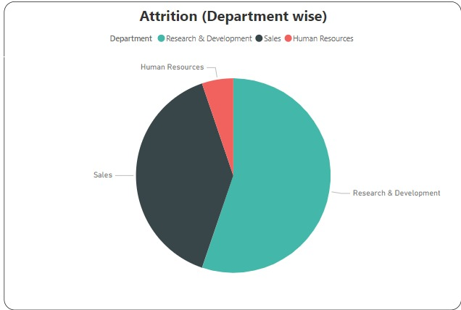

**ii. Attrition Count by Education Field:**

Creating visualizations for attrition across various education fields is instrumental in pinpointing areas with higher attrition rates. This exploration provides insights into the relationship between education backgrounds and attrition, guiding targeted retention efforts and talent management strategies.

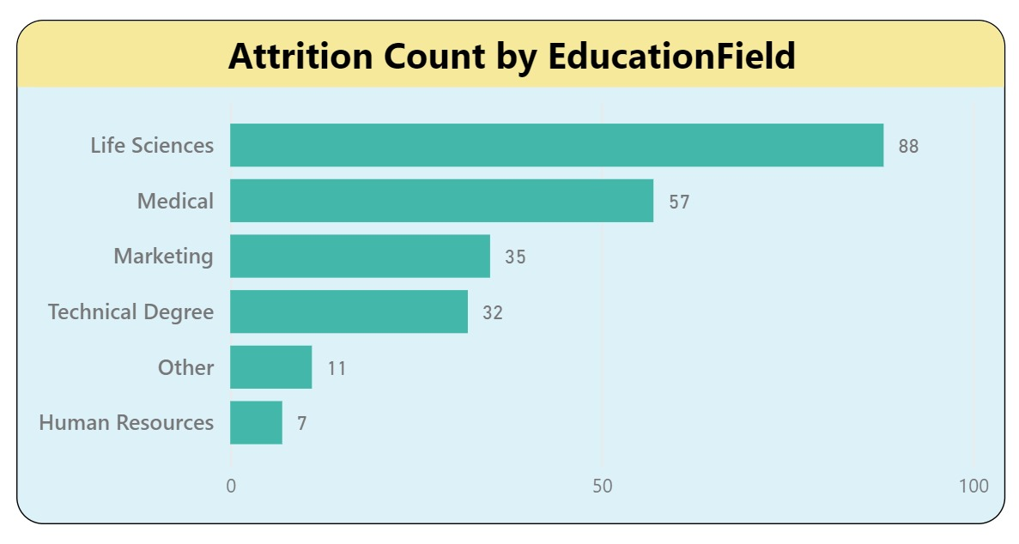

**iii. Attrition Department-wise:**

Visualizing attrition department-wise offers a clear depiction of how attrition is distributed across different organizational units. This analysis is invaluable for identifying departments that may be more susceptible to attrition, allowing for focused interventions and strategies to improve retention.



**IV. Employee Count by Age Group:**

Examining the distribution of employees across different age groups provides essential insights into age diversity within the organization. This visualization helps HR professionals understand the age demographics of their workforce, enabling the development of inclusive policies and practices.

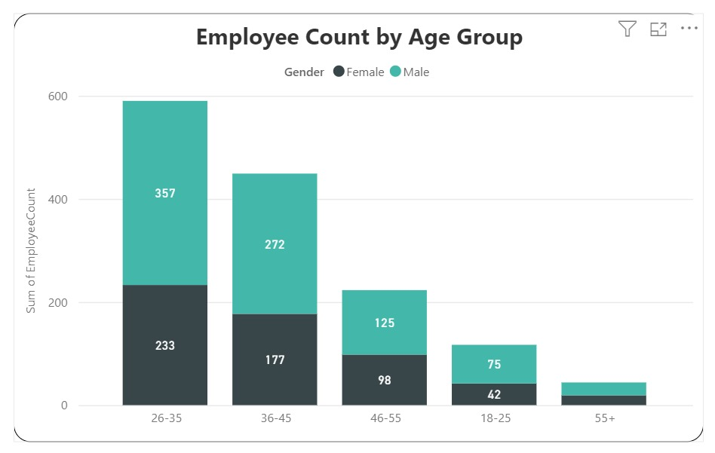

**V. Job Satisfaction Rating:** Utilizing visualizations to assess job satisfaction ratings and identifying contributing factors is crucial for gauging employee sentiment. This exploration guides HR strategies aimed at enhancing job satisfaction and creating a positive work environment.

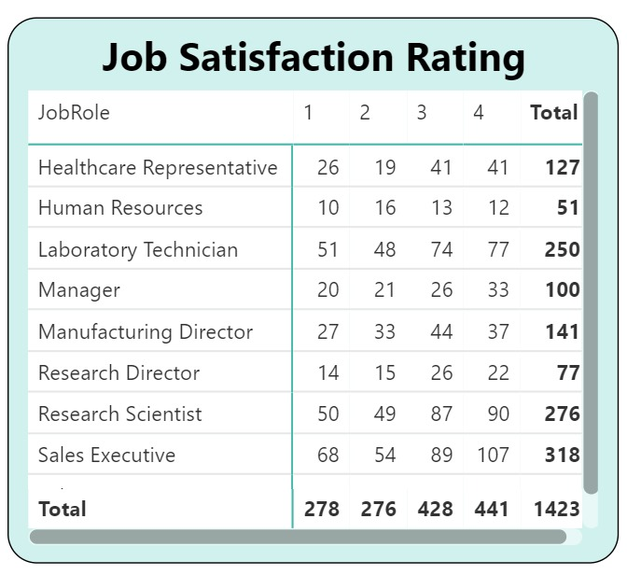

**Dashboard:**

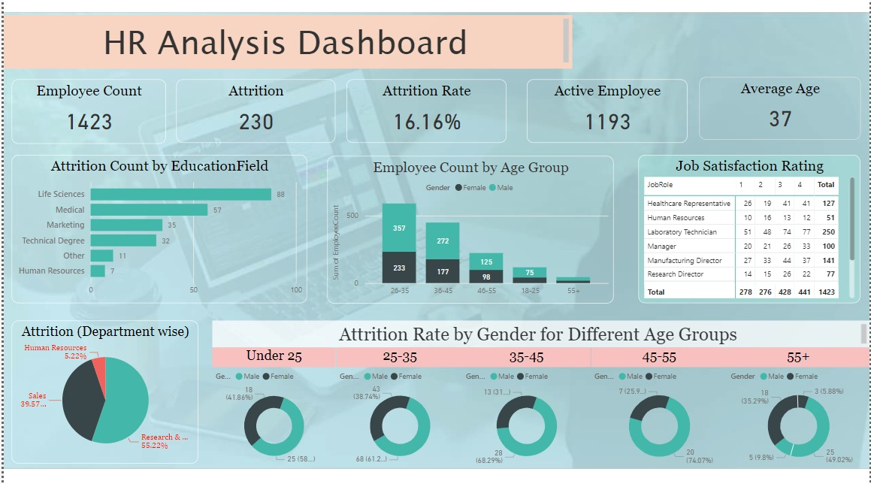

**c. Observations and Insights:**

**Age Trends:**

During the exploratory analysis, a diverse age distribution within the workforce became apparent, suggesting a multigenerational composition. Recognizing the potential impact of age on variables like job satisfaction and attrition rates, there is a planned investigation into whether certain age groups exhibit distinct patterns in these aspects. Understanding age-related dynamics can provide valuable insights for tailoring HR strategies, training programs, and employee engagement initiatives to cater to the diverse needs and preferences of different age cohorts.

**Attrition Patterns:**

Noteworthy observations reveal variations in attrition rates across different education fields and departments. This raises questions about potential correlations between job roles, educational backgrounds, and attrition. The intention is to conduct a more in-depth analysis to uncover the underlying factors contributing to attrition within specific segments of the workforce. By identifying these correlations, HR strategies can be refined to address department-specific challenges and create targeted retention programs tailored to the unique characteristics of each educational field.

**Job Satisfaction Correlations:**

The exploration uncovered potential correlations between job satisfaction levels and factors such as job involvement. Recognizing these relationships opens avenues for a deeper dive into understanding the specific factors influencing job satisfaction. Further analysis will aim to pinpoint the drivers of employee contentment, enabling organizations to implement targeted interventions to enhance job satisfaction, boost employee morale, and foster a more positive work environment.

**Gender-Age Attrition Dynamics:**

Preliminary observations hint at the existence of potential gender-age-specific attrition trends within the dataset. This intriguing insight prompts a focused exploration to comprehend the nuances and factors contributing to attrition in these specific groups. By delving deeper into gender-age dynamics, organizations can tailor retention strategies that address the unique challenges and preferences associated with different demographic segments, fostering a more inclusive and supportive workplace culture.

**V. Future Steps:**

Moving forward, the analysis will extend to explore additional relationships between variables, providing a comprehensive understanding of the factors influencing workforce dynamics. The investigation will include a closer look at outliers and subsets exhibiting notable patterns, allowing for a more nuanced interpretation of the data. Refinement of the analysis based on specific challenges identified during the initial exploration will guide subsequent steps, ensuring a targeted and effective approach in addressing workforce-related concerns.

**Conclusion**

The exploration of HR data through visualizations has provided valuable insights into various aspects of the workforce. Analyzing age distribution helps in understanding generational trends, while attrition patterns across education fields and departments offer targeted areas for retention strategies. Examining employee demographics by age group supports the development of inclusive HR policies. Job satisfaction visualizations contribute to enhancing employee engagement and well-being. Exploring attrition rates by gender and age group aids in addressing diversity challenges.

Additionally, visualizing key variables like Monthly Income and Distance From Home provides a comprehensive understanding of factors influencing HR dynamics. The decision to skip visualizing constants or variables with limited variability demonstrates a focus on meaningful insights. Overall, this exploratory data analysis lays the foundation for informed HR decision-making and strategic workforce management.

**References & Articles:**

"Leveraging HR Analytics for Talent Management" - This article discusses the importance of HR analytics in talent management and provides examples of how data analysis can lead to better hiring decisions and employee development.

**Link:**

<https://www.linkedin.com/pulse/how-hr-analytics-transforming-talent-management-strategiesafricdsa/#:~:text=Through%20the%20utilization%20of%20advanced,the%20development%20of%20future%20leaders>.

"The Role of Predictive Analytics in HR" - This article explores how predictive analytics can be applied to HR processes, such as workforce planning, employee turnover prediction, and recruitment.

**Link:**

<https://web.s.ebscohost.com/abstract?site=ehost&scope=site&jrnl=09760245&AN=125855371&h=2VikwQ5jg2Nw8LsQ1Hqr0EZNqWO4xNx%2fxWXFzrT4gaZDun7PD8PcvEzMCBczSuoxsi%2fnrqrRUbQwBMkL%2buiYOQ%3d%3d&crl=c&resultLocal=ErrCrlNoResults&resultNs=Ehost&crlhashurl=login.aspx%3fdirect%3dtrue%26profile%3dehost%26scope%3dsite%26authtype%3dcrawler%26jrnl%3d09760245%26AN%3d125855371>

"Big Data in Human Resources: A Practical Guide" - This article provides practical insights into using big data for HR decision-making, including the use of advanced analytics and tools.

**Link:** <https://www.mdpi.com/2076-0760/8/10/273>